Senior Design I EML 4551C

Team 520: Simulated Assembly Line and Processing Workstation
Functional Decomposition

FAMU-FSU College of Engineering
2525 Pottsdamer St, Tallahassee, FL 32310


Team Members:
David DiMaggio: dcd14@my.fsu.edu
Cheyenne Laurel: crl15d@my.fsu.edu
Boluwatife Olabiran: boluwatife1.olabiran@famu.edu
Nataajah Taylor: nataajah1.taylor@famu.edu
Joell Williams: joell1.williams@famu.edu

Faculty Advisor:
Dr. Dorr Campbell

Sponsor:
Tallahassee Community College

Instructor:
Dr. Shayne McConomy

Functional Decomposition Flow Chart

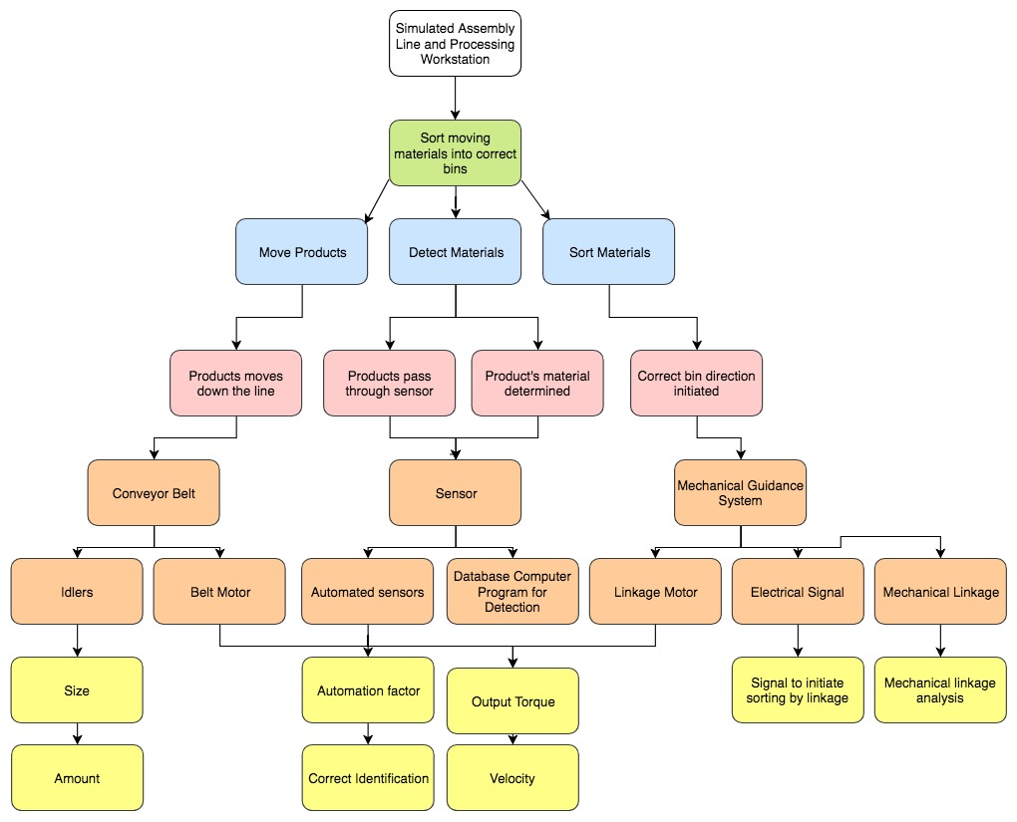

Functional Decomposition Table

Based on the table below, the most important components of our system include the Mechanical Guidance System that will be used to direct each material into the proper bin, and the electrical signal necessary to initiate the sorting by linkage, since those processes are required to achieve the three main functions. With this information, the group will be focusing on these two components and their measurable inputs and outputs in order to achieve the main functions.

